Sprint-3

**Team ID** : PNT2022TMID05047

# **IBM ID** : IBM-Project-8846-158934532

**Project Title** : Industry-specific intelligent fire management system

**Project Development CODE:**

#include <WiFi.h>//library for wifi #include <PubSubClient.h> #include "DHT.h"// Library for dht11

#define DHTPIN 15 // what pin we're connected to #define DHTTYPE DHT22

DHT dht (DHTPIN, DHTTYPE);// creating the instance by passing pin and typr of dht connected

void callback(char* subscribetopic, byte* payload, unsigned int payloadLength);

//-------credentials of IBM Accounts------

#define ORG "vg9s67"//IBM ORGANITION ID

#define DEVICE_TYPE "sprint003"//Device type mentioned in ibm watson IOT Platform #define DEVICE_ID "spsprint003"//Device ID mentioned in ibm watson IOT Platform #define TOKEN "1234567890" //Token

String data3;

float Humidity, Temp;

//-------- Customise the above values --------

char server[] = ORG ".messaging.internetofthings.ibmcloud.com";// Server Name

char publishTopic[] = "iot-2/evt/Data/fmt/json";// topic name and type of event perform and format in which data to be send

char subscribetopic[] = "iot-2/cmd/command/fmt/String";// cmd REPRESENT command type AND COMMAND IS TEST OF FORMAT STRING

char authMethod[] = "use-token-auth";// authentication method char token[] = TOKEN;

char clientId[] = "d:" ORG ":" DEVICE_TYPE ":" DEVICE_ID;//client id

//

WiFiClient wifiClient; // creating the instance for wificlient

PubSubClient client(server, 1883, callback ,wifiClient); //calling the predefined client id by passing parameter like server id,portand wificredential

void setup()// configureing the ESP32

{

**Serial**.begin(115200);

dht.begin(); delay(10); **Serial**.println(); wificonnect(); mqttconnect();

}

void loop()// Recursive Function

{

Humidity = dht.readHumidity(); Temp = dht.readTemperature(); **Serial**.print("Temp:"); **Serial**.println(Temp); **Serial**.print("Humidity:"); **Serial**.println(Humidity); PublishData(Temp,Humidity); delay(1000);

if (!client.loop()) { mqttconnect();

}

}

/*.....................................retrieving to Cloud */

void PublishData(float Temp, float Humidity) { mqttconnect();//function call for connecting to ibm

/*

creating the String in in form JSon to update the data to ibm cloud

*/

String payload = "{\"Temp\":"; payload += Temp;

payload += "," "\"Humidity\":"; payload += Humidity;

payload += "}";

**Serial**.print("Sending payload: ");

**Serial**.println(payload);

if (client.publish(publishTopic, (char*) payload.c_str())) {

**Serial**.println("Publish ok");// if it sucessfully upload data on the cloud then it will print publish ok in Serial monitor or else it will print publish failed

} else {

**Serial**.println("Publish failed");

}

}

void mqttconnect() {

if (!client.connected()) {

**Serial**.print("Reconnecting client to ");

**Serial**.println(server);

while (!!!client.connect(clientId, authMethod, token)) {

**Serial**.print("."); delay(500);

}

initManagedDevice();

**Serial**.println();

}

}

void wificonnect() //function defination for wificonnect

{

**Serial**.println(); **Serial**.print("Connecting to ");

WiFi.begin("Wokwi-GUEST", "", 6);//passing the wifi credentials to establish the connection while (WiFi.status() != WL_CONNECTED) {

delay(500);

**Serial**.print(".");

}

**Serial**.println(""); **Serial**.println("WiFi connected"); **Serial**.println("IP address: "); **Serial**.println(WiFi.localIP());

}

void initManagedDevice() {

if (client.subscribe(subscribetopic)) { **Serial**.println((subscribetopic)); **Serial**.println("subscribe to cmd OK");

} else {

**Serial**.println("subscribe to cmd FAILED");

}

}

void callback(char* subscribetopic, byte* payload, unsigned int payloadLength)

{

**Serial**.print("callback invoked for topic: ");

**Serial**.println(subscribetopic);

for (int i = 0; i < payloadLength; i++) {

//Serial.print((char)payload[i]); data3 += (char)payload[i];

}

}

# Simulation:

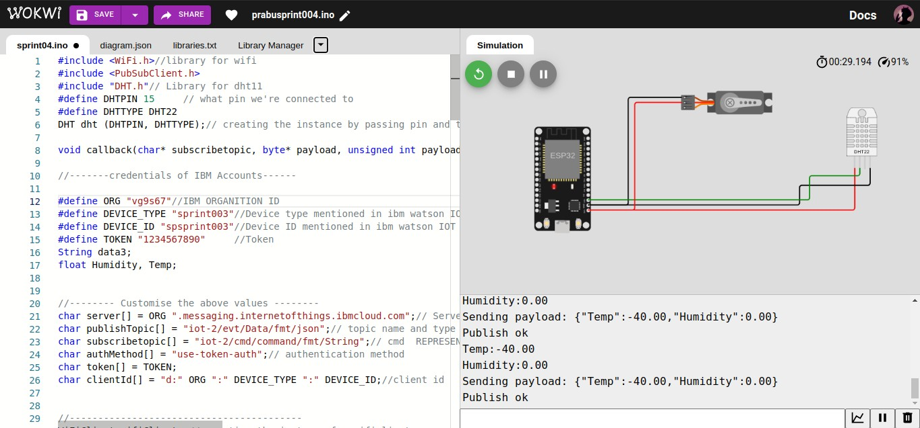

ibm cloud connection:

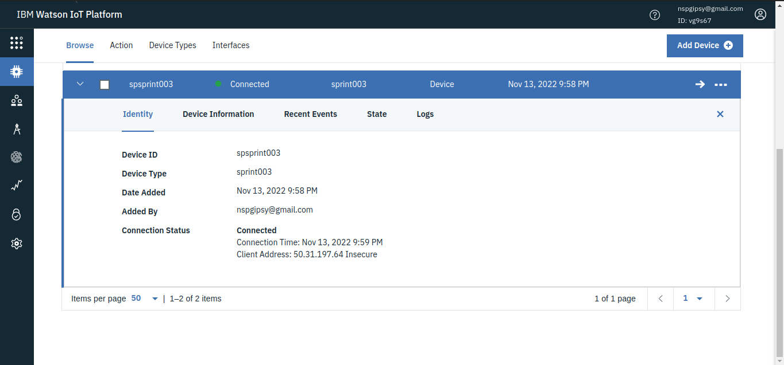

# output in ibm cloud:

